****

**ABOUT OUR COMPANY**

**Prabhukripa Solutions Private Limited is most acclaimed private sector Security & Manpower Solutions Company.**

We are extremely delighted in introducing ourselves as pioneer and professional in Security & Allied Services with best effort to provide services in various establishments in central and state Government, MNCs, Hospitals, Institutions, Industries, Residences, warehouses and factories all over Uttar Pradesh. We are most acclaimed private sector security company in India and specialized in pioneering large scale Civil/Tech Security and also developing new age Security & Consultancy arrangements.

Prabhukripa Solutions Private Limited is growing company for providing security services (Armed / Unarmed) in Lucknow. We provide Security Guards, Armed and Unarmed, Lady Guards, Bouncers, Personal Bodyguards, Receptionists, Man Power Supplies etc. Our company is a professionally managed and handled by an good professionals and it has already made its presence felt and is bound to reach Newer Heights with cooperation and support of clients. We are pleased to introduce ourselves as a reliable and recognized Security agency in India, Our Agency consists of voluntary retired army, defence, police and other uniformed serviced candidates. We specialize in offering our customers with world class professional security services that meets the variegated requirements of our customers. Our professionals engaged in offering these services are highly experienced and assists our customers with respect to potential and also vulnerabilities.

**Mission**  
We are committed to provide comprehensive solutions for varied security and surveillance needs. To continuously evolve process and train professional towards creating a safe and secure environment for people.

**Vision**  
Emerge as one of the top 10 organizations in the surveillance and security with the efficient use modern technology to skilfully combat, counter minimize and ultimately prevent threat and risk to life and assets of our client globally.

**Our Strength**

Training is the core strength of the security industry and in specific to Prabhukripa Solutions, where training and acquired skills of security personnel would be the sole determining factor at the time of need of our client. Training and Development begins when our personnel joins Prabhukripa Solutions Private Limited and continues throughout their tenure.

# OUR TEAM

|  |  |
| --- | --- |
| G:\z0ebc2eb3-3a6c-4515-9429-dd518d64b118\1. Prabhukripa Solutions Private Limited\Director_1_Lokesh Singh\Lokesh_Photo.jpg | **Lokesh Kumar Singh (Director)**  Mr. Lokesh Kumar Singh is the Director of the Company. He has more than 12 years’ experience in the field of providing complete client satisfaction. He is also the promoter of M/s Prabhu Associates and M/s Kavya Constructions, which is solely managed by him. |

|  |  |
| --- | --- |
| G:\Kalpana Singh_Photo.JPG | **Dr. Kalpana Singh Rathour (Director)**  Dr. Kalpana Singh Rathour is the Director of the Company. She completed her M.Phil and Phd. from Jawaharlal Nehru University, New Delhi. She is the good speaker and strength of the Company. |

|  |  |
| --- | --- |
| G:\z0ebc2eb3-3a6c-4515-9429-dd518d64b118\1. Prabhukripa Solutions Private Limited\Director_3_Niharika Singh\Niharika Singh Photo.jpeg | **Niharika Singh (Director)**  Niharika Singh is the Director of the Company. She is B.Tech and MBA from Sherwood College of Management, Lucknow. She is the good Entrepreneur. She is also the promoter of M/s PNL Entrepreneur, which is solely managed by him. |

|  |  |
| --- | --- |
| G:\z0ebc2eb3-3a6c-4515-9429-dd518d64b118\1. Prabhukripa Solutions Private Limited\Website Development\Ramu Singh.jpeg | **Raghav Singh (Mentor)**  Mr. Raghav Singh is the mentor of the Company. He is the Chartered Accountant by profession and Fellow member The Institute of Chartered Accountants of India. He has more than 9 years’ experience in the field of providing consultancy services & complete client satisfaction. |

# OUR SERVICE

**[Security Guards](http://www.chetaksecurity.in/services.html" \o "Seervice Title)**

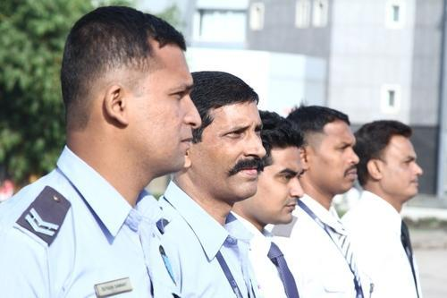

We are offering 24/7 Service to our valued clients. Our Prabhukripa Solutions Private Limited are highly trained by our experts and offer best services. Apart from this, we also offer rapid Corroborations of our expert Guards in any emergency situation. The services offered by us are known for flexibility, reliability and responsibility. A Physical guarding service is based on the support and communications between internal, site and operations managers. Our well trained security guards help to maintain and to create "well secure" environment for the management and employees by their manners and etiquettes, round the clock surveillance on the perimeter and internal assets, information sharing and communication skills.

## [Bouncers](http://www.chetaksecurity.in/services.html" \o "Service Title)

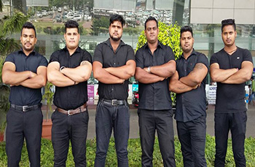

The bouncers are mostly engaged to protect the events, summit, or meetings that happen at the resorts, night clubs, or any other venues, mostly outdoor locations. Bouncers from Prabhukripa Security are all well-built, uniformed, and trained to handle the crowds and the party behavior during late nights. The bouncers will be provided with modern gadgets and sometimes arms and equipments to protect the large crowd gathered. Our bouncers will check the legal age and will ask for an age proof or documentation to check the entrance of minors Having Security arrangements in all such places is very crucial and Intelligence Security Services have all solution for such situation. We can provide bouncers in an event & our services can be completely customized as per client’s requirement.

## [Armed and Unarmed Security](http://www.chetaksecurity.in/services.html" \o "Service Title)



Prabhukripa Solutions Private Limited offers both armed and unarmed security guard services. Available 24/7, you will find our carefully recruited security officers to be professional, responsive, and reliable. We will work with you to determine the appropriate level of protection, understanding that each client’s situation is unique and can change at any time. All of our security officers must pass a background investigation that includes criminal, credit, and reference checks and drug screening. They must be of sound character, demonstrate good judgment, and present a neat and professional appearance.

## [Man Power Supplies](http://www.chetaksecurity.in/services.html" \o "Seervice Title)



Manpower is the prime driving force behind any successful venture. It is the availability of quality manpower at a reasonable price that often determines the profitability and success of a business. Sourcing of manpower is one of the biggest challenges faced by an organisation because it is time consuming and involves considerable efforts. It is due to this reason that manpower supply is usually outsourced to contractors who are specialised in supplying human resources. They recruit and train individuals from various locations and make their labour available to businesses at their factories or offices.

## [House Keeping](http://www.chetaksecurity.in/services.html" \o "Seervice Title)

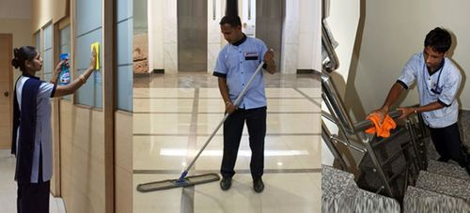

We offer our clients professional housekeeping services. The different types of services that we offer are cleaning & housekeeping services, office housekeeping services, apartment housekeeping services, corporate housekeeping services, include Domestic & official housekeeping services provide by MNC, also provide vacuum service like cars, sofa chair, carpet, curtain fans, valuable furniture etc...

## [Events](http://www.chetaksecurity.in/services.html" \o "Seervice Title)



Event management begins with the booking of talent and venue, but ultimately entails so much more. From arranging location, to securing contract details, event management specialists know how to take care of the details. We can help recommend talent according to the type of crowd you wish to draw, and help you figure out how best to stretch your budget.

# CONTACT US NOW

**Regd. Office:** 8A/213, Sector-8A, Vrindavan Yojna, Raibareilly Road, Lucknow – 226029

**Call Us 24 Hours / 7 Days**

G:\z0ebc2eb3-3a6c-4515-9429-dd518d64b118\1. Prabhukripa Solutions Private Limited\Website Development\images.jpg (+91) 9838507000

G:\z0ebc2eb3-3a6c-4515-9429-dd518d64b118\1. Prabhukripa Solutions Private Limited\Website Development\images (1).jpg prabhukripasolutions@gmail.com